# Portfolio activity:

# Algorithm for file updates in Python

## Scenario

I am a security professional working at a health care company. As part of my job, I'm required to regularly update a file that identifies the employees who can access restricted content. The contents of the file are based on who is working with personal patient records. Employees are restricted access based on their IP address. There is an allow list for IP addresses permitted to sign into the restricted subnetwork. There's also a remove list that identifies which employees you must remove from this allow list.

## Project description

Create an algorithm that uses Python code to check whether the allow list contains any IP addresses identified on the remove list. If so, you should remove those IP addresses from the file containing the allow list.

## Open the file that contains the allow list

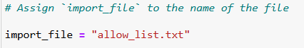

To open the file that contains the allow list i first assigned “import_file” to the file i want to open “allow_list.txt”.

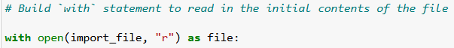

And then I built a ‘with’ statement to read in the initial contents of the file, in order for me to do so i needed to add the open () function and use parameter 1 for the variable i had assigned earlier on “import_file” to open the file stored in that variable in the second parameter of the “open()” function i typed in “r” which reads the file, “as file:” assigns the now opened file to a new variable “file”.

The above code would not output anything because it was not assigned(coded) to.

If you do try it will just show an error saying “unexplained EOF”[EOF means End Of File]

## Read the file contents

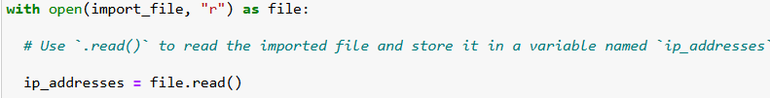

I created a new variable “ip_addresses” so that it can store the string that's about to be created from the file. I then placed the newly created “file.read()” so that it converts the contents of the “allow_list.txt” file into a string so that it can be read .

Convert the string into a list

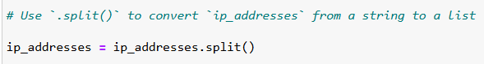

I added the variable “ip_addresses = ip_addresses.split()” so that i could convert the file which i had previously changed into a string so that i could now make it a list by using “.split”.

split() changes string into list

## Iterate through the remove list

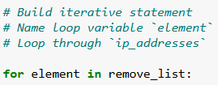

I now start a “for” loop with the loop variable of "element" that will loop through the “remove_list”

## Remove IP addresses that are on the remove list

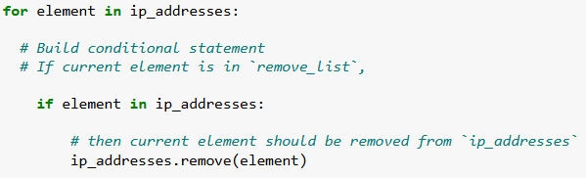

I then typed in “ip_addresses.remove(element)” which will now remove all the Ip addresses that are in the remove_list

## Update the file with the revised list of IP addresses



The .join() method combines all items in an iterable into a string. The .join() method is applied to a string containing characters that will separate the elements in the iterable once joined into a string. In this algorithm, I used the .join() method to create a string from the list ip_addresses so that I could pass it in as an argument to the .write() method when writing to the file "allow_list.txt". I used the string ("\n") as the separator to instruct Python to place each element on a new line.

Then, I used another with statement and the .write() method to update the file:

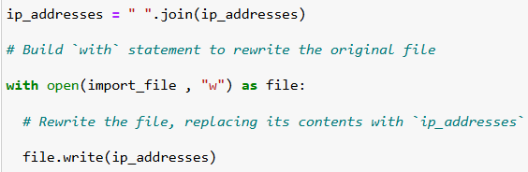

This time, I used a second argument of "w" with the open() function in my with statement. This argument indicates that I want to open a file to write over its contents. When using this argument "w", I can call the .write() function in the body of the with statement. The .write() function writes string data to a specified file and replaces any existing file content.

## 

## Summary

In this portfolio i created an algorithm by using the following:

I used the with statement and the open() function

Used .read() and .write() methods to read the file and to make some changes to the file by writing in them

Used .split() method to change string that was in the file so that it’s data type could become a list

Used a for loop so that so that a variable “element” could iterate through the remove_list

Used .remove() method to remove “elements” from the ip_addresses variable.

The following is all the code that wasted in this portfolio(On the next page)

